**Name:S.Prakul 192210073**

**EXP 5:Create a Cloning of a VM and Test it by loading the Previous Version/Cloned VM**

**Step 1:choose VM clone**

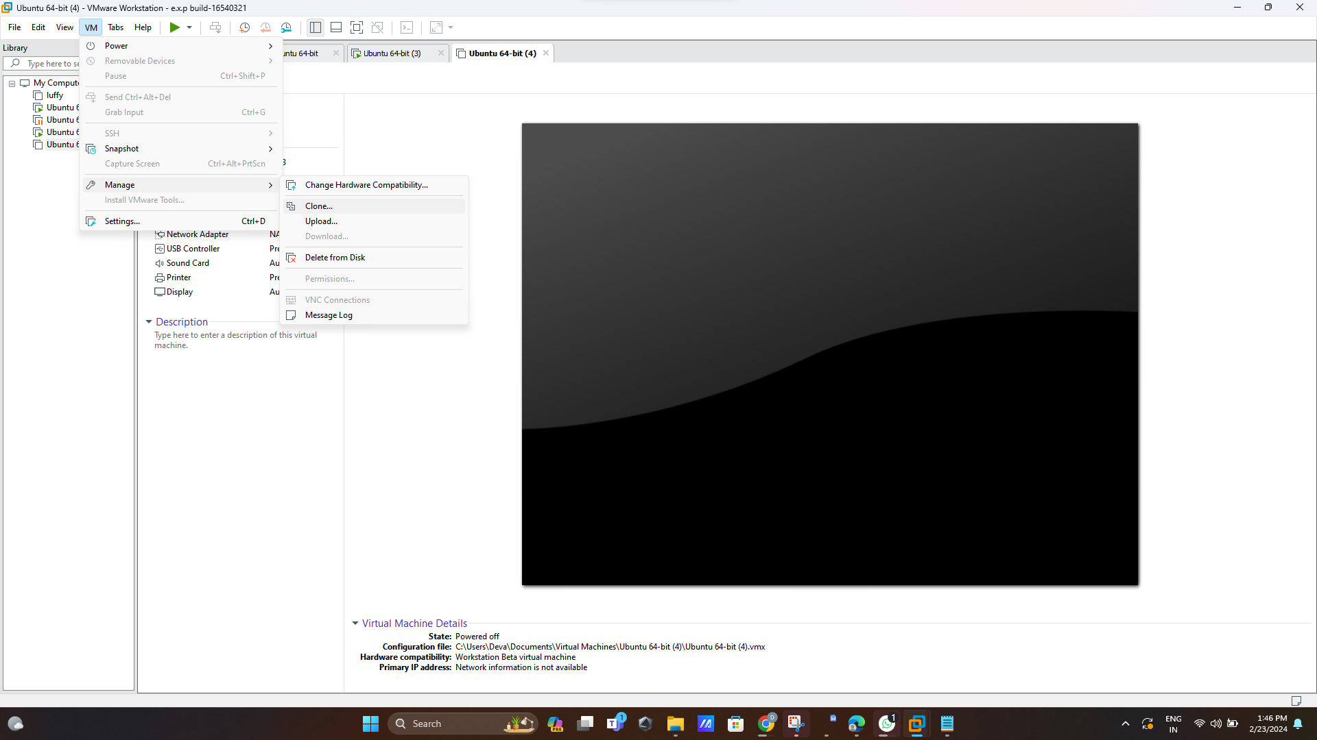

**Step 2:clone from current state**

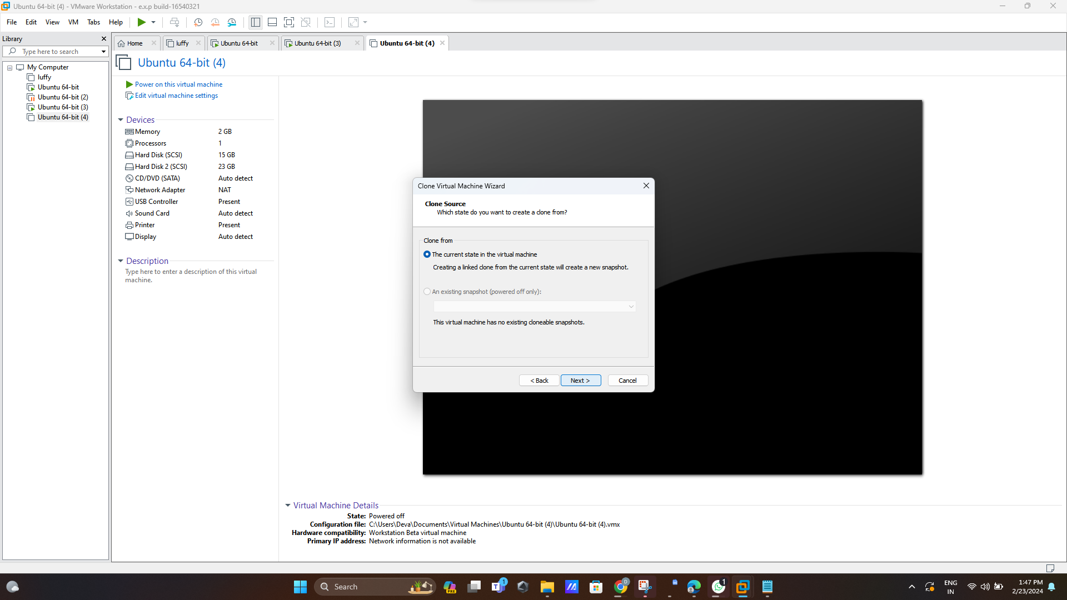

**Step 3:create full clone**

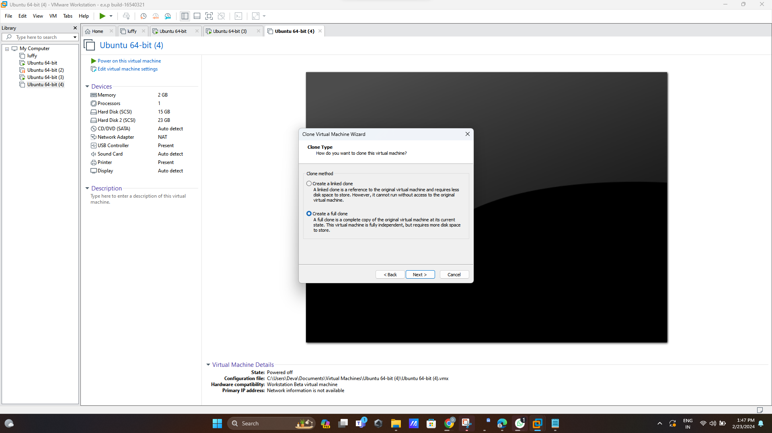

**Step 4:name the clone**

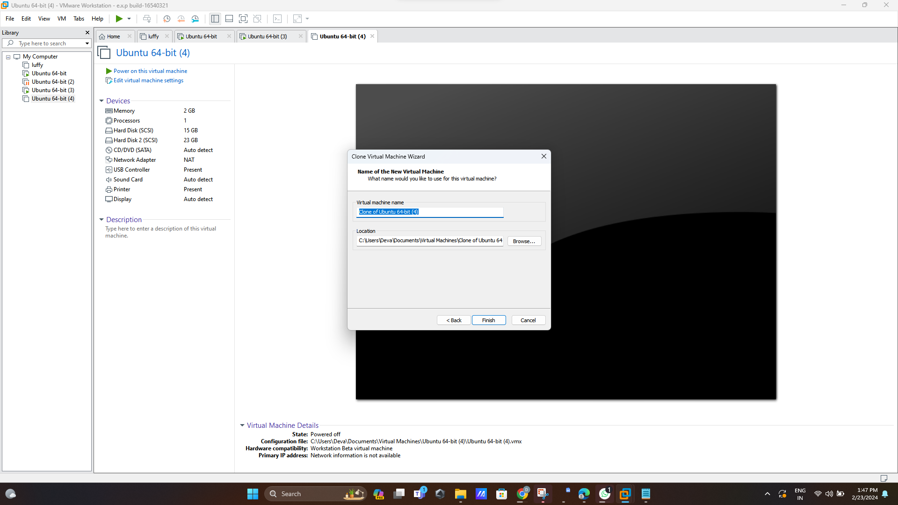

**Step 5:Final output of this project**

